TASKS :

1. Create a unique listing of all jobs that are in department 30. Include the location of

department in the output.

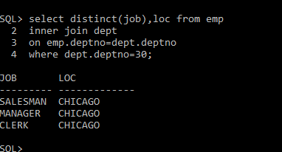

2. Write a query to display the employee name, department name and loc of all employees who

earn a commission.

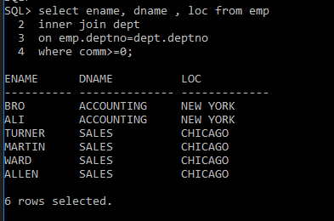

3. Create a query that displays the name, job, department name, salary, and grade for all

employees.

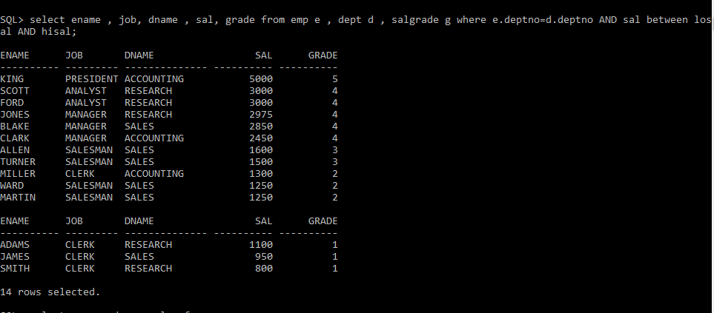

4. Create a query to display the name and hire date of any employee hired after employee

ADAMS.

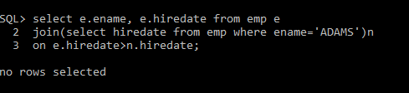

5. Display the names and hire dates for all employees who were hired before their managers,

along with their manager’s names and hire dates.

